Staverton Road
Daventry
Northamptonshire
NN11 4HW
Tel: (01327) 705785
www.thegrange.northants.sch.uk

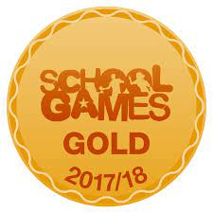
15th July 2021

Dear Parents & Carers
Another parent has made me aware that there were Year 1 children outside the school grounds this morning, at the school gate.
We have been very clear that we are following Government guidance instructing you that your Year 1 children should be self-isolating, regardless of whether they have symptoms. Anyone who is self-isolating should not be leaving your house.
If you are unable to bring other children to school, they too should stay at home and engage with learning remotely. Their absence will be marked as COVID-related and discounted from any attendance calculations for this year.
COVID19 has not gone away and, in fact, rates are rising within the community. Please ensure that you follow all COVID guidance.
Regards
Vicki Masters

